**Database creation, Table Creation and Data Insertion**

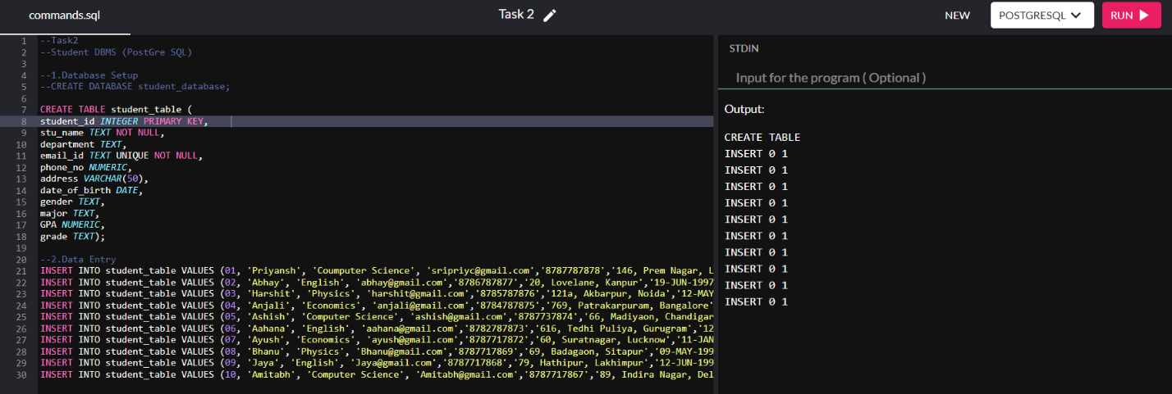

**3. Develop a query to retrieve all students' information from the "student_table" and sort them in descending order by their grade.**



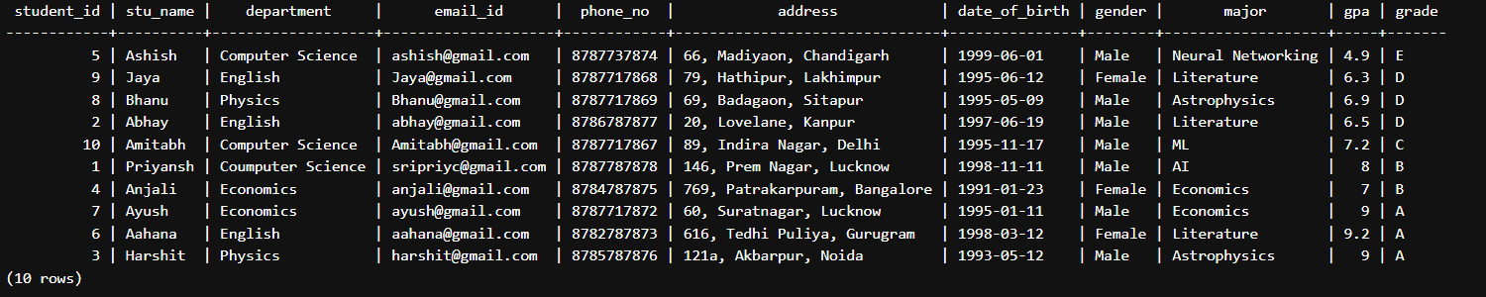

**4. Implement a query to retrieve information about all male students from the "student_table."**



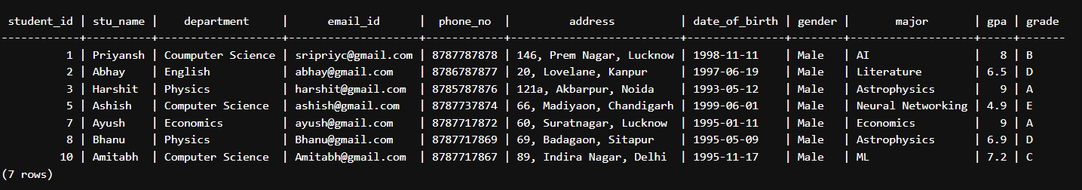

**5. Create a query to fetch the details of students who have a GPA less than 5.0 from the "student_table."**





**6. Write an update statement to modify the email and grade of a student with a specific ID in the "student_table."**

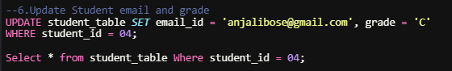



**7. Develop a query to retrieve the names and ages of all students who have a grade of "B" from the "student_table."**



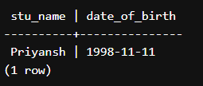

**8. Create a query to group the "student_table" by the "Department" and "Gender" columns and calculate the average GPA for each combination.**

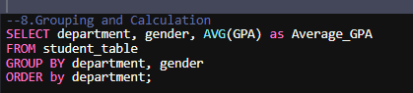

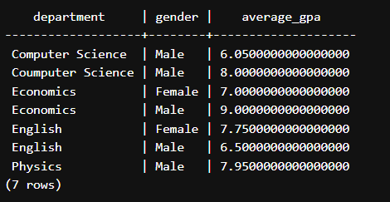

**9. Rename the "student_table" to "student_info" using the appropriate SQL statement.**





**10. Write a query to retrieve the name of the student with the highest GPA from the "student_info" table.**



